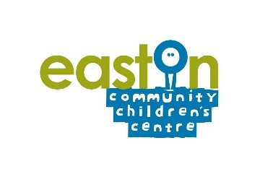
Dear Parents & Carers,

There has been a recent increase in cases of routine childhood infectious diseases in the South West. This has been caused by normal infection levels being significantly reduced for the last two years and it is expected that incidents will continue to rise as wider mixing continues.

Chickenpox

Chickenpox is very common and affects most children, usually in early childhood. Whilst chickenpox can be very uncomfortable for the child, it is usually a mild self-limiting infection. Chickenpox is highly infectious, and cases of chickenpox are generally infectious to others from 2 days before the rash appears to 5 days after the onset of the rash. To reduce transmission within settings, cases are required to stay at home until all lesions have crusted over. Paracetamol and antihistamine medicine can also be administered to help with any pain and discomfort. However, ibuprofen should not be administered, unless advised by a doctor, as this can increase the risk of serious skin infections. If there are concerns about a child’s symptoms the parent/carer should seek medical advice.

Advice on how to manage chickenpox is available here: https://www.nhs.uk/conditions/chickenpox/

Scarlet fever

Scarlet fever is also a common, usually mild, childhood infection caused by the bacteria known as group A Streptococcus (GAS). These bacteria may be found on the skin, throat (“strep throat”) and other sites where they live without causing any problems. Under some circumstances GAS can cause non-invasive infections such as pharyngitis, impetigo and scarlet fever. The symptoms of scarlet fever can be flu-like including a high temperature, sore throat, and swollen neck glands. It is then characterised by a red, generalised pinhead rash, typically beginning on the chest and stomach 12-48 hours after first symptoms, which then rapidly spreading to other parts of the body. On more darkly pigmented skin, the scarlet rash may be harder to spot, but it should feel like 'sandpaper'. The face can be flushed red but pale around the mouth.

Cases of scarlet fever should be treated with antibiotics to reduce the risk of complications and onward transmission. If a child has symptoms of scarlet fever, it is important that they see their GP. Children can return to their setting 24 hours after commencing antibiotic treatment (so long as they are well enough to do so). If no antibiotics are administered, they will be infectious to others for 2-3 weeks and so will require an extended isolation period.

Advice on how to manage scarlet fever is available here: https://www.nhs.uk/conditions/scarlet-fever/

In any situation, if parents are concerned about how unwell a child or adult is, they should seek advice from their pharmacy, GP or NHS 111. In an emergency, call 999 or go to A&E.

